Screenshots demonstrating the project results and functionality.

Setup and connectivity (rubric: Mininet + SDN, initial testing)
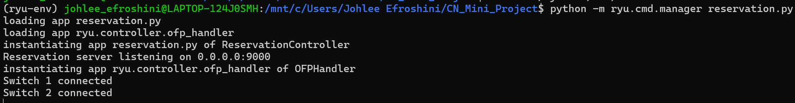
1. Ryu starts the reservation server on port 9000 and connects both SDN switches.
ryu_running.png
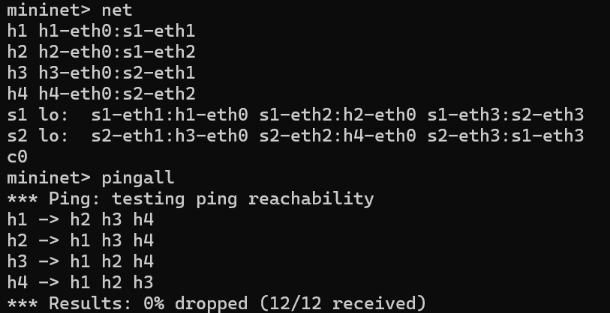
2. Mininet shows four hosts and two switches, with all 12 ping tests succeeding.
mininet_topology.png

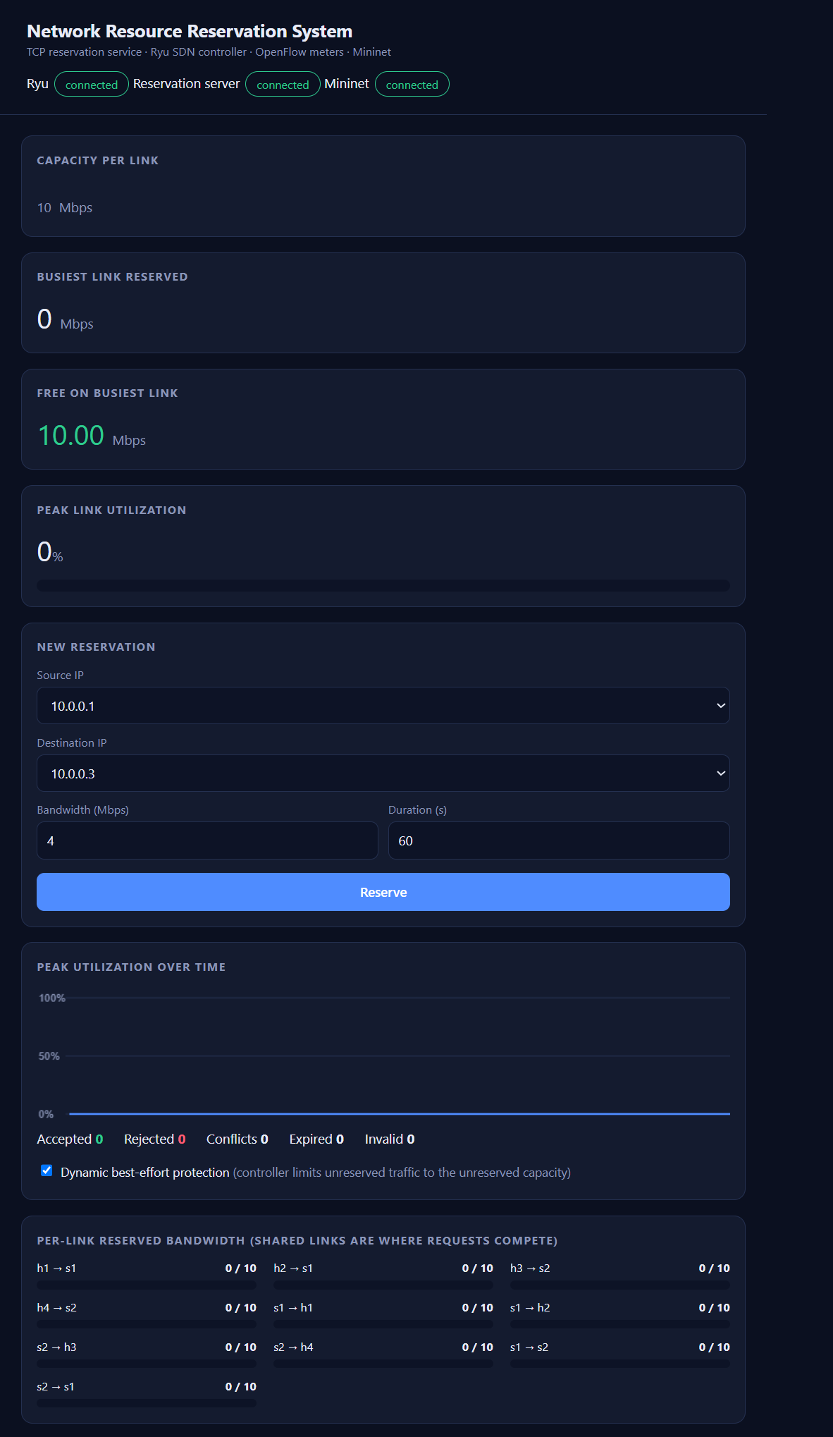
3. The portal shows connected services, 10 Mbps link capacity, and no active reservations.
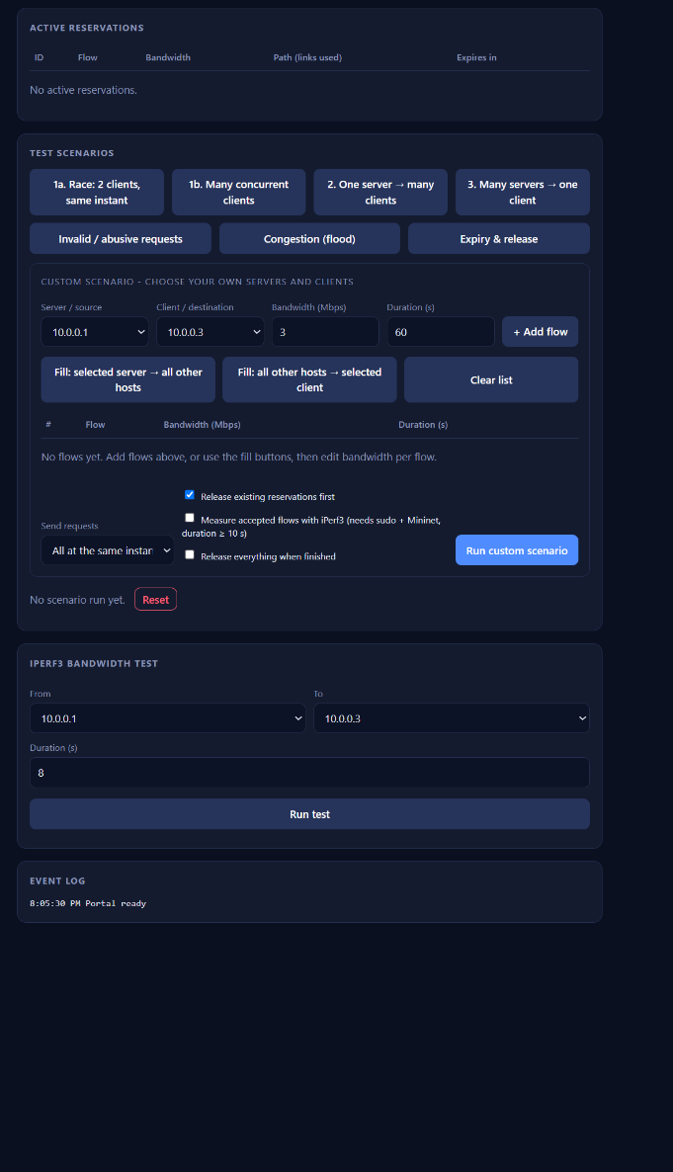
4. The portal provides scenario testing, iPerf3 measurements, and an event log.
portal_overview.png
- TCP service and functionality (rubric: socket implementation, application functionality)
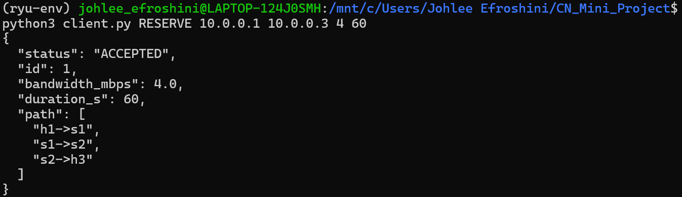
5. The TCP client receives acceptance for a 4 Mbps reservation from h1 to h3 for 60 seconds.
tcp_client_accepted.png

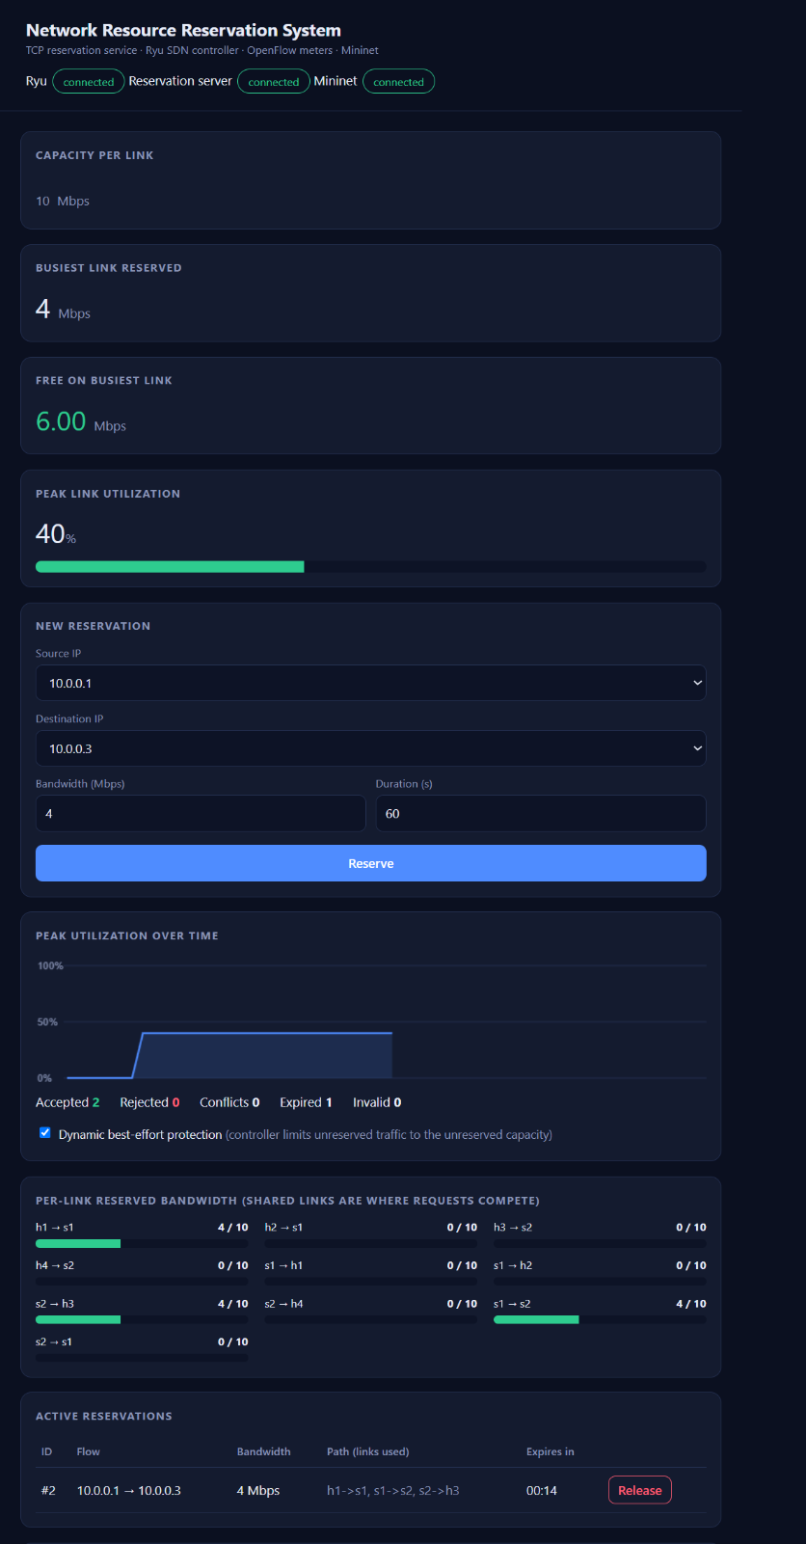
6. An active 4 Mbps reservation leaves 6 Mbps free and uses 40% of the busiest link.
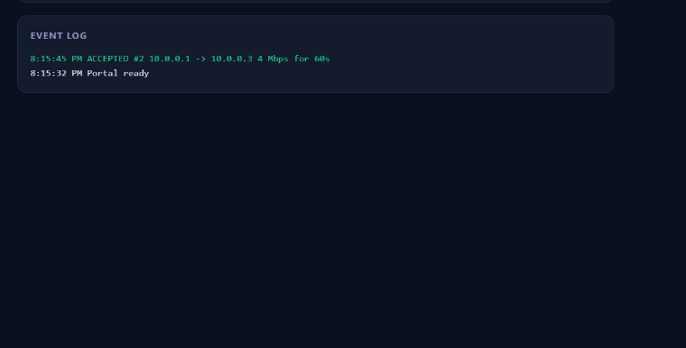
7. The event log confirms acceptance of the 4 Mbps reservation from 10.0.0.1 to 10.0.0.3.
portal_reservation.png
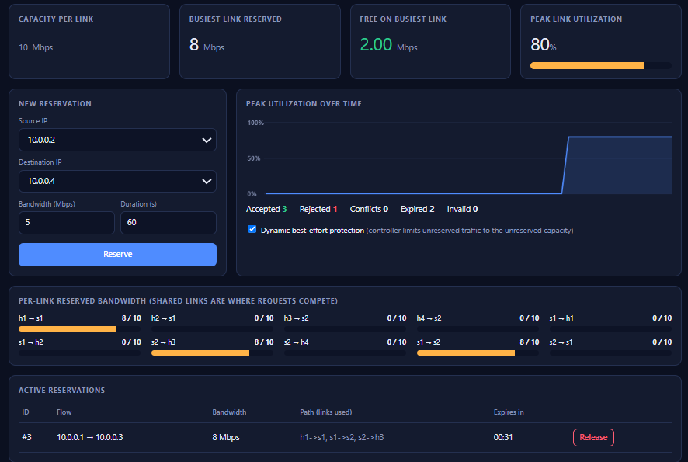
8. An 8 Mbps reservation leaves only 2 Mbps free on the shared 10 Mbps link.
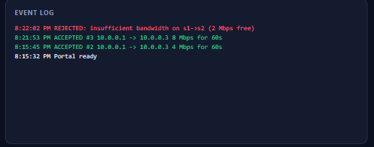
9. The log rejects a request because the shared s1-to-s2 link has only 2 Mbps available.
rejected_bottleneck.png

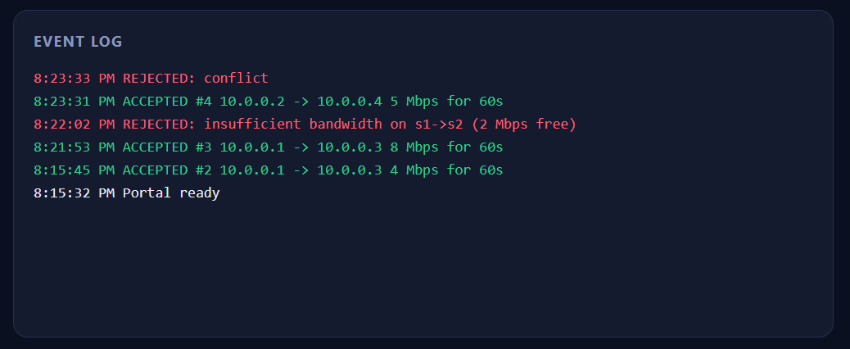
10. The event log records a conflict rejection after accepting a 5 Mbps reservation.
conflict.png

- SDN policy evidence (rubric: flow rules, socket to SDN integration, dynamic SDN)
11. OpenFlow rules apply meter 5 to the reserved flow and meter 60000 to best-effort traffic.
dump_flows.png

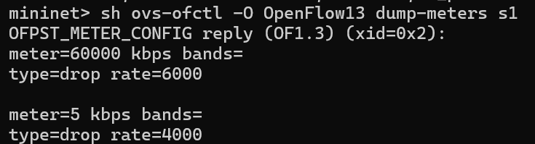
12. The switch meters limit reserved traffic to 4 Mbps and best-effort traffic to 6 Mbps.
dump_meters.png

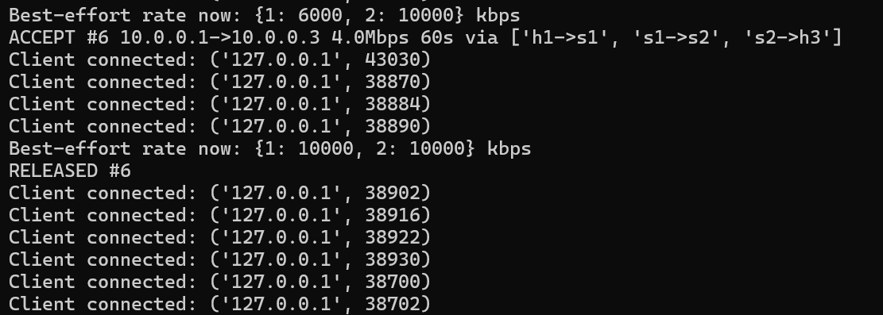
13. Ryu logs acceptance and release, restoring best-effort capacity after the reservation ends.
ryu_log.png

- Enforcement with iPerf3 (rubric: performance evaluation)
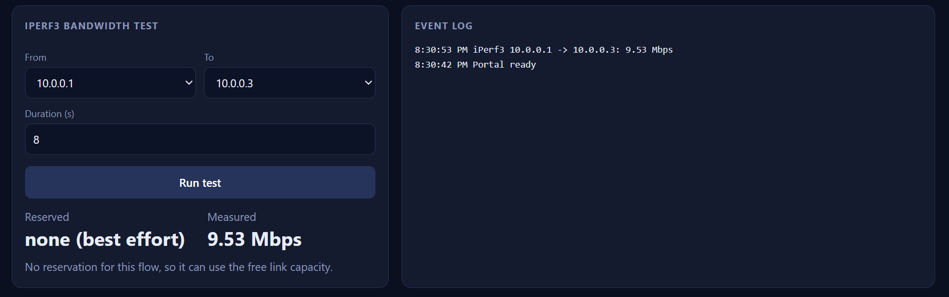
14. Without a reservation, iPerf3 measures 9.53 Mbps for best-effort traffic from h1 to h3.
iperf_no_reservation.png

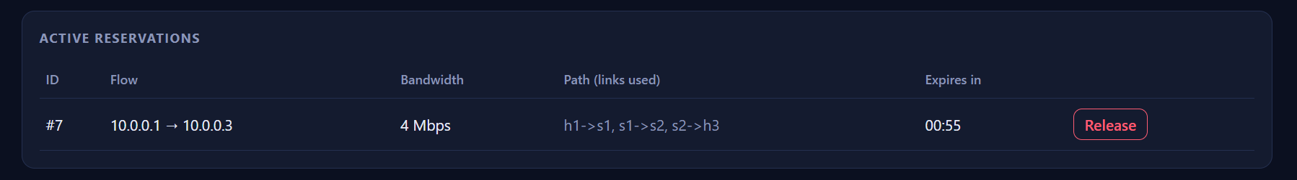
15. The portal lists an active 4 Mbps reservation from h1 to h3 with 55 seconds remaining.
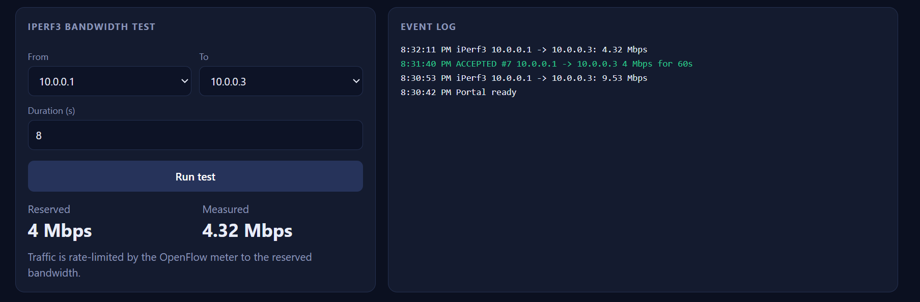
16. With a 4 Mbps reservation, iPerf3 measures 4.32 Mbps, close to the configured rate.
iperf_reserved.png

- Scenarios (rubric: challenging scenario, performance comparison, complete functionality)
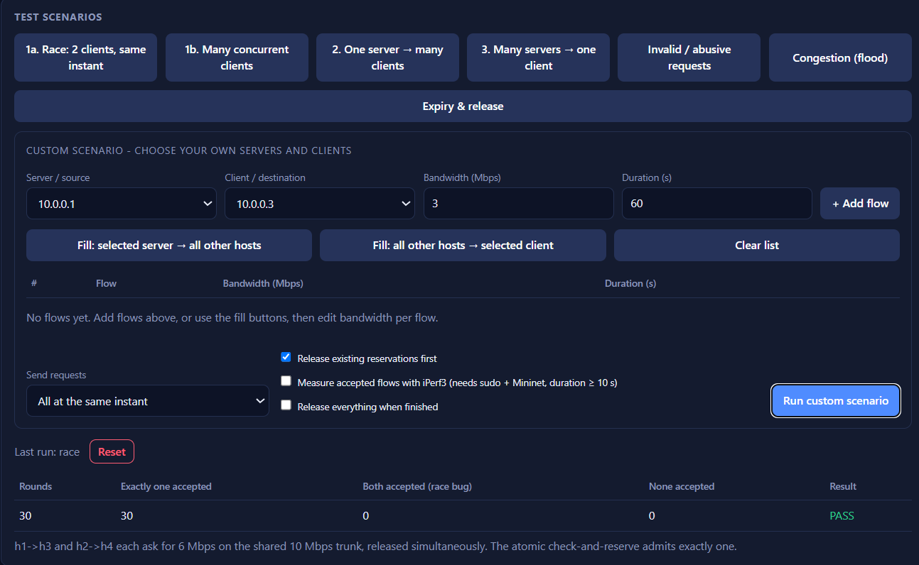
17. All 30 race-test rounds accept exactly one competing request, with no double acceptance.

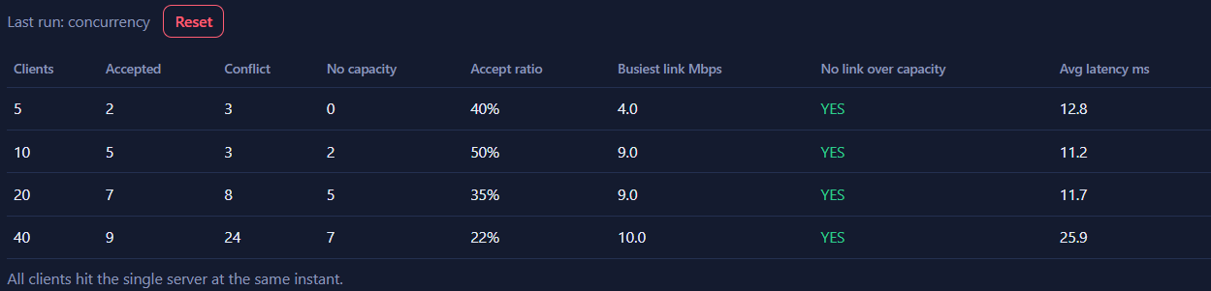
18. Tests with 5 to 40 concurrent clients keep every link within its bandwidth capacity.

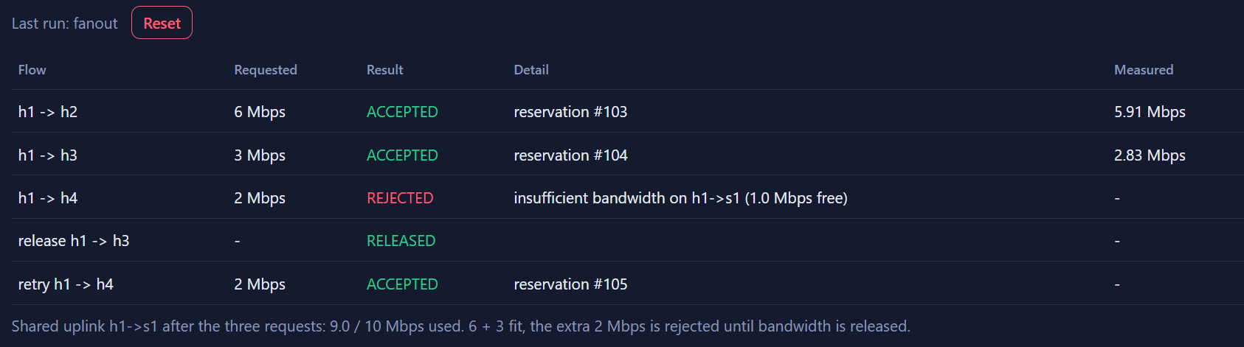
19. Fan-out testing accepts 6 and 3 Mbps flows; a rejected 2 Mbps flow succeeds after release.

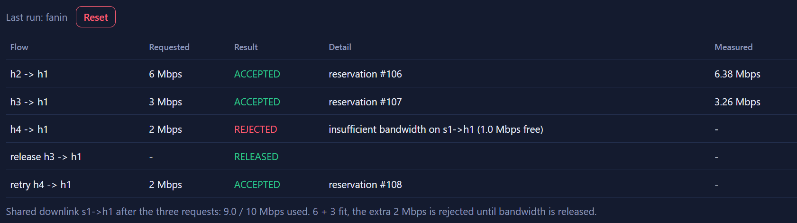
20. Fan-in testing accepts 6 and 3 Mbps flows; a rejected 2 Mbps flow succeeds after release.

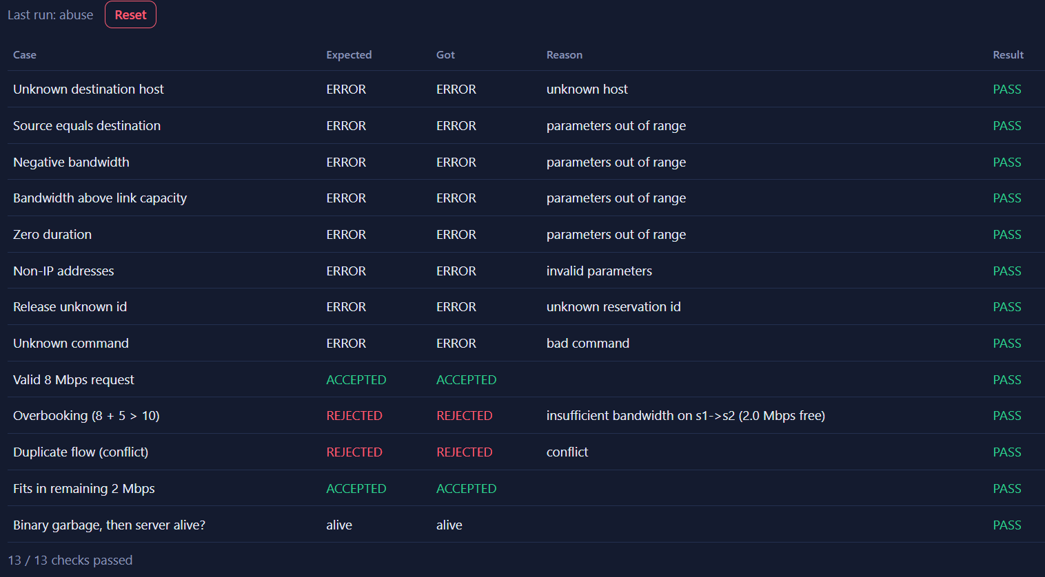
21. All 13 validation checks pass, covering invalid inputs, overbooking, conflicts, and server survival.

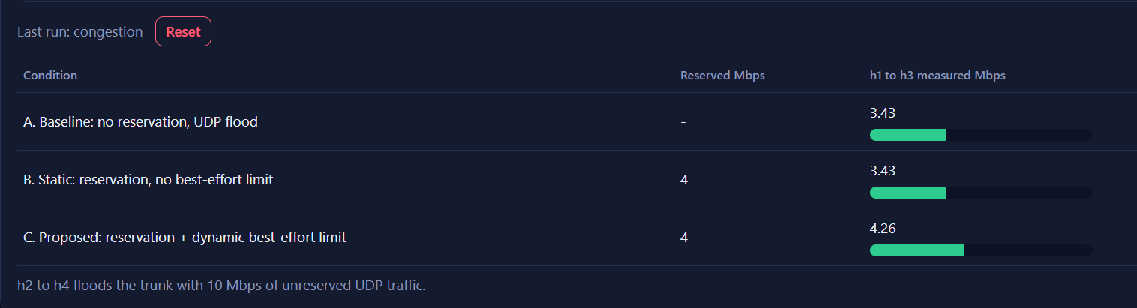
22. Under UDP flooding, dynamic best-effort limiting raises throughput from 3.43 to 4.26 Mbps.

